Assistive Technology Applications for Literacy Lessons

1. The candidate used a Big Mack switch (See Below) to record the repetitive line, “What Time is it Mr. Crocodile?” from the book. Although the student could not read the text aloud, he would be able to participate in shared reading by pressing the switch at the right time on every other page of the interactive book where the repetitive line occurred.
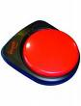
Big Mack Switch
Available through www.ablenetinc.com
--------------------------------------------------------------------------------------------
2. The student was able to work on beginning sounds from words in the story when the candidate developed a bright visual using Boardmaker. (See Below)

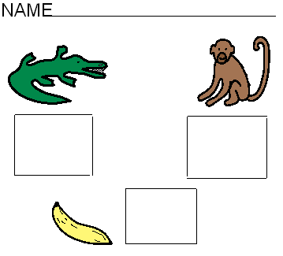
Boardmaker word work
Available from www.mayer-johnson.com

-----------------------------------------------------------------------------------------
3. The student was so enthusiastic about Power Point books (See link), the candidate decided to create one for him. She had learned how to make the book during the methods class and by accessing the tutorial at: http://www.setbc.org/setbc/accessiblebooks/freebooksforyou.html
The student had a fondness for teddy bears and the color blue. The element of surprise at the end of the Power Point book delighted and motivated him to read. (See Below)

Page 1 Page 2 Page 3
Page 4 Page 5 Page 6
Page 7 Page 8 Page 9
PowerPoint book created by candidate
------------------------------------------------------------------------------------------------------------
4. In order to use the Power Point books, the student needed to operate the computer mouse effectively to turn the pages, but was not able use a traditional mouse. The candidate used an adapted computer mouse (See Figure 5) from the local assistive technology lending library that methods candidates had visited earlier in the semester.
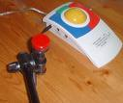
Adapted computer mouse (see www.rjcooper.com)
------------------------------------------------------------------------------------------------------------
5. Another form of technology that the candidate was able to utilize with her student was the Go Talk 9, (available through the Attainment Company, Inc. www.attainmentcompany.com) a programmable voiced output device with different overlays each with 9 choices of pictures or images to choose from. Digital text on the computer proved to be a powerful motivator for the student, both during structured literacy sessions and for informal reading during recess, with a friend. Prior to the candidate’s practicum, the student’s recess routine was primarily supported by a paraprofessional. To increase the time and quality of interactions with typical peers, Jess created an overlay for recess that allowed Adam to ask a friend to join him for various activities such as listening to music or reading a book on the computer.(See Below)

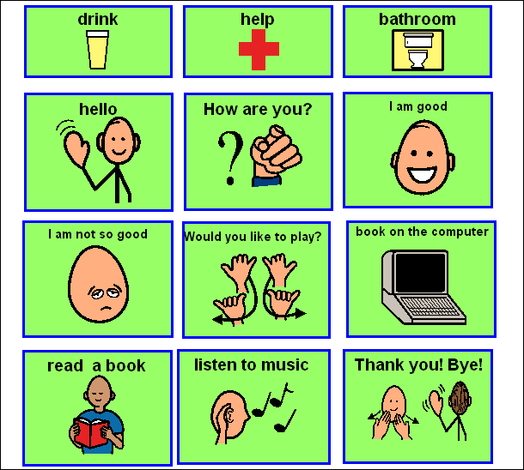

Recess Routine Overlay for Go Talk 9
-----------------------------------------------------------------------------------------------

